Lab 05 - Packages and DNS
Table of Contents
Introduction 1
Packages 1
Updating and Upgrading 2
Installing a Package 2
Package Integrity 3
Configuring BIND (DNS) 3
Network Settings 4
DNS Configuration 4
External DNS 5
Testing External DNS 8
Internal DNS 10
Set ns2 to use DHCP 10
Change Hostname to ns2 11
Assign MAC Address Reservation for ns2 11
Update BIND db files. 12
Nagios 15
Port Forwarding for DNS services on ns2 17

Introduction
This lab explains Domain Name System (DNS) functions. This lab will teach you the skills required to install and maintain various programs and services, and show you how to install, configure, and test your own DNS server. You should also become more familiar with DNS requests and the services provided by a DNS server.

Over the next few weeks, you will be installing a series of servers. Read over the DNS Overview document to help build an understanding of how DNS will be setup in this course. We will be building all these services together over the next several weeks. Please DO NOT start building any of these services yet. The names are for DNS purposes only.

**********************************************************************************************************
The following activities will be done on the cpre230_<netid>_ubuntu_ns1. DO NOT use your desktop (Ubuntu_Desktop). USE YOUR ns1 box.

*********************************************************************************************************

Packages
Packages are bundled binaries, configuration files, and scripts used to install, update, remove and generally maintain various programs in a Linux distribution. Ubuntu and Debian use the apt package system (front end for dpkg), Fedora uses dnf, Arch pacman, etc. (every distribution of Linux comes with a package manager of some sort). Applications installed via the packaging system allow for easy management, while applications installed manually (compiling source, copying, configuring, etc.) need to be manually updated by the user as updates are issued.

apt is a very powerful tool and can help administrators perform a wide variety of tasks. Some of the most common commands are listed below with a brief description:

- apt install <package>
  - Install the specified package from the repository and any required dependencies.
- apt remove <package>
  - Remove the specified binaries for the specified package. Leaves dependencies and configuration files.
- apt purge <package>
  - Remove everything in a package (binaries and config files). Dependencies are kept.
- apt autoremove
  - Remove all orphaned packages, which were automatically installed to satisfy dependencies for other packages but are no longer listed as dependencies of any currently installed package.
- apt update
  - Update the package database from the online repo. Note that this does not update any packages.
- apt upgrade
  - Upgrade all installed packages to the latest version in the package database. This operation will never remove packages, which may prevent some package upgrades.
- apt full-upgrade
  - Upgrade all installed packages and remove any that must be removed to upgrade the system ("smart" upgrade).
- apt search <package>
  - Search package names and descriptions in the package database.
- apt show <package>
  - Show detailed information about the specified package

Updating and Upgrading
As was instructed in early labs, a system can be upgraded by issuing the following commands:

sudo apt update
sudo apt full-upgrade

This will pull in the latest data from the online repository and then upgrade the existing packages accordingly. It is recommended that you review and patch systems often to keep the most up-to-date security patches.

Installing a Package
It is a good idea to research a package before installing. This can help identify problematic dependencies, conflicts, size issues, etc. In this lab, we will be setting up a DNS server called bind9. Search for the bind9 package. Display its detailed information to the terminal. Take a screenshot and include it in the lab write up (piping to less might help if it doesn’t all fit on the screen).

After viewing its details install the bind9 package. There shouldn’t be any conflicts or warnings. (sudo apt install …..)

Package Integrity
Another important aspect of packages is verifying whether they have been modified or not. To do this, we will use debsums. Using apt, install this package.

After installing debsums, run debsums init. This command will generate file hashes for any packages that didn’t already have any. File hashes are used as a point of comparison to ensure that nothing about the original file content has changed. For practice, using man, figure out how to output all files that have been changed. When you run this command (format: sudo debsums -[insert flag here] sl), it shouldn’t output anything because nothing has been changed or tampered with. (The ns1 machine might output some files due to different configurations we have)

For demonstration purposes, we are going to install a useless program called sl (steam locomotive) - go ahead and install it via the commands described above. Now we are going to tamper with a file. Specifically, we are going to tamper with a file from the package sl. To verify all the packages from steam locomotive only, run debsums sl. It should output all the files it is checking with "OK" to the right of them. Pick one of these files and open them with nano or vi.

Next enter text anywhere to change the file in some manner. Then save and close the file. Now run the command you found earlier for checking changed files and it should only output the file you changed. Take a screenshot of that command and its output (i.e. the file that failed the check).

Now if we ever find a package that has a tampered-with file, we can try to figure out what changed manually, or we can reinstall the package. To reinstall sl, run the following command.

sudo apt reinstall sl

Now verify the sl package once again and the package should now be okay.

Configuring BIND (DNS)
DNS is important for maintaining a network, as it allows machines and services to be offered and configured without using hardcoded IP addresses. This makes restructuring of a network, reissuing of IP addresses, and moving of servers much more manageable. It is important to think of DNS as a type of phonebook that maps a name to an IP address, and that a DNS server merely offers a lookup service for clients. DNS servers themselves follow a hierarchy, such that ISELab declares itself responsible for any machine within the 230.com domain and takes on the role of directing clients to DNS servers which are the authority in various sub-domains (e.g., student43.230.com).

Network Settings
Before proceeding any further, we need to change the nameservers entry to the VM's own IP address.

- Open the network configuration file, depending on what you named it in Lab 2, /etc/netplan/00-installer-config.yaml or /etc/netplan/01-netcfg.yaml
- Below the nameservers and addresses lines, you should see the current nameserver of 199.100.16.100. You need to change this to your machine's own IP address (XXX.XXX.XXX.200). Ensure that you keep the indentation. This means your network will query your DNS, not ISELab's.
- After saving and closing the file, apply the changes with the following command.
sudo netplan apply
- You should be able to type the following command to confirm that you are now using the local box for DNS queries.
resolvectl status
You should see near the end of the output that the "DNS Servers" entry matches what you configured. If it does not, double check your network config file for errors.

Ensure that you have some place to keep track of your DNS entries and which IPs they map to One such location is in the vSphere notes tab:
- Go to the VM's Summary tab in vSphere.
- In the Notes section, click "Edit Notes…" and enter your IP and other relevant information. This will be useful for quick switching between VMs.

DNS Configuration
The program for maintaining our naming server is BIND (Berkeley Internet Name Domain). This will allow the machines on your network to communicate internally using domain names. This article may be useful to review before starting to perform the installation.

The following instructions assume you have installed the bind9 package. If you have not, refer to the instructions above to complete the installation. Once you have done this, continue below.

You will be running a split DNS for your network. All DNS queries from the external network (the "Internet") will only return information we want to expose to the outside world (sanitized information), with the corresponding external address. The external DNS server is ns1.studentXX.230.com which will be at the IP X.X.X.200.

Once you configure the external DNS server, you will clone it and change/add the configuration for your internal network. Queries from inside our private network will return the corresponding internal address for the requested service. This will allow less information to be leaked to the outside world and internal queries to be kept within our network. The internal DNS server will be ns2.studentXX.230.com which will be at the IP 192.168.1.200 (which will be assigned using MAC address reservation on your pfSense firewall).

External DNS
First you will configure a forwarder nameserver. This is just like adding your ISP's DNS server to your system. However, in our case, it will be the IP address of 199.100.16.100 which will be used. In the ISELab environment, you can think of that IP as providing your upstream DNS service.

- Open the BIND configuration file, /etc/bind/named.conf.options.
- Go to the forwarders section and delete the "//" on each of the 3 lines. The "//" indicates that the rest of the line is a "comment" and should be ignored by the file parser, essentially deactivating the section.
- Change the IP address from 0.0.0.0; to 199.100.16.100;.
  - Be sure to keep the ";".
- Set “dnssec-validation” to “no”.
- Comment out the listen-on-v6 since ISEAGE does not use IPv6.
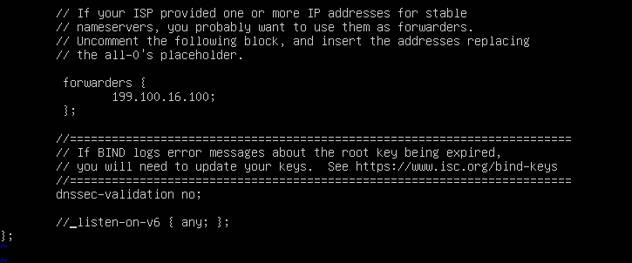
- Save and close the file. After that, restart the DNS server.
sudo systemctl restart bind9
- Test the cache nameserver by using dig or nslookup for iastate.edu.
  - Your request should resolve.

Next you will configure bind9 to be the primary DNS for your domain/zone. You will do this by first editing a DNS lookup file, /etc/bind/named.conf.local.

Add in the following information, substituting your student number and your reverse IP address. Remember, if your IP address network is 37.56.23.0, then your in-addr.arpa zone would be 23.56.37.in-addr.arpa.
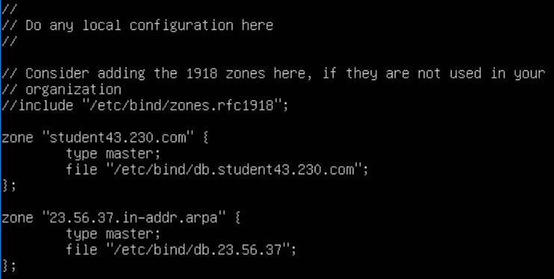
Now comes the building of the forward resolution for the primary name server. It is easiest if you copy the "dummy" file db.local to your forward lookup file name. Remember, the XX is the number in your student username (as found in the network information spreadsheet).

sudo cp /etc/bind/db.local /etc/bind/db.studentXX.230.com

Next, edit the file /etc/bind/db.studentXX.230.com using nano or vim.
(It is easier to do this in vim, as nano does not show colors and vim does)

Make your record looks like the screenshot below where the differences are your own IP address and set the serial number to the date (format: yyyymmdd) with a number appended to it, which you increase each time you modify the file. We won't be adding an MX record just yet, but we will be making an address record (A) for mail.

Make sure you change the TTL value on the first line.

If you review the DNS overview document, you see that only one machine stays in the public IP space, but four of them need public DNS records. ns1 does not have an internal IP if you look at the list. It stays outside the firewall. You will put www, www2, and mail behind the firewall, but still allow access to the outside. This is somewhat realistic of what happens in the real world. Often there are multiple routers and firewalls protecting our servers (or the cloud services we use). That complexity is outside the scope of your network in this class. We will only use one firewall to protect our servers.

Now build the reverse resolution file. The easy way is to copy the file /etc/bind/db.127 to /etc/bind/db.XXX.XXX.XXX where the Xs indicate your IP address with the octets reversed.

sudo cp /etc/bind/db.127 /etc/bind/db.XXX.XXX.XXX

Then edit the file to make it look like the one below.
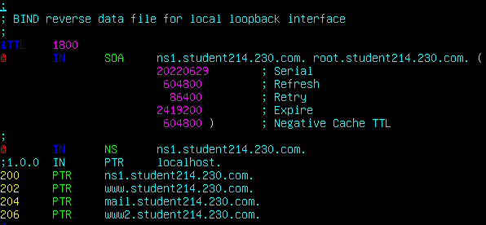
Confirm that there were no typos by executing the following command. If you have errors, read the message, then try troubleshooting the error yourself by reviewing your files and/or googling the error.

named-checkconf
named-checkzone studentXX.230.com /etc/bind/db.studentXX.230.com

Now, restart the bind9 service.

sudo systemctl restart bind9

Confirm that there were no errors with the following command. (Errors about network unreachable for DNSKEY are not a problem). If there are errors, try troubleshooting the error yourself by reviewing your files and/or googling the error.
sudo systemctl status bind9

Testing External DNS
You will conduct many forward and reverse lookups on your own infrastructure, as well as another student’s infrastructure.

To perform a forward lookup DNS query, run the command:

dig [YourHostname] +noall +answer

If your query resolved correctly, you would see output similar to the following:

To perform a reverse lookup DNS query, run the command:

dig -x [IPAddress] +noall +answer

If your query resolved correctly, you would see output similar to the following:

Note: When you perform a forward lookup, you provide a hostname, and you should get an IP address as your output. When you perform a reverse lookup, you provide an IP address and should get the hostname as your output.

If you make a mistake with your DNS records, you may need to run the following command on the machine from which you conducted the query. This deletes any information on DNS stored in the local machine’s cache.

sudo resolvectl flush-caches

With the information above, test your machines. First use the forward lookup information by asking for the machine name. You should be able to determine the hosts IP address this way. Take a screenshot of the output from these commands doing forward lookups:

dig ns1.studentXX.230.com +noall +answer
dig www.studentXX.230.com +noall +answer
dig mail.studentXX.230.com +noall +answer
dig www2.studentXX.230.com +noall +answer

Use the reverse lookup information by providing an IP address to return the names of each server. Take a screenshot of the output from these commands doing reverse lookups:
dig -x XX.XX.XX.200 +noall +answer
dig -x XX.XX.XX.202 +noall +answer
dig -x XX.XX.XX.204 +noall +answer
dig -x XX.XX.XX.206 +noall +answer

Now, query someone else's servers and IPs to verify they are working (like the person sitting beside you or maybe a close friend from Discord). Again, screenshot the four forward lookups and the four reverse lookups. They should resemble the dig commands above.

You should have 8 total queries on your personal infrastructure (4 forward + 4 reverse) and 8 queries on another student’s infrastructure. (4 forward + 4 reverse). Note: All your queries (forward/reverse lookups) need to resolve on both your infrastructure and another student’s infrastructure to get credit

Internal DNS
You could create a whole new Ubuntu server and install bind9, but a shortcut is to clone your existing external DNS server (ns1) to a copy named ns2 which will be used as your internal DNS server.

- In vSphere, right-click your ns1 machine and select "Clone" -> "Clone to Virtual Machine".

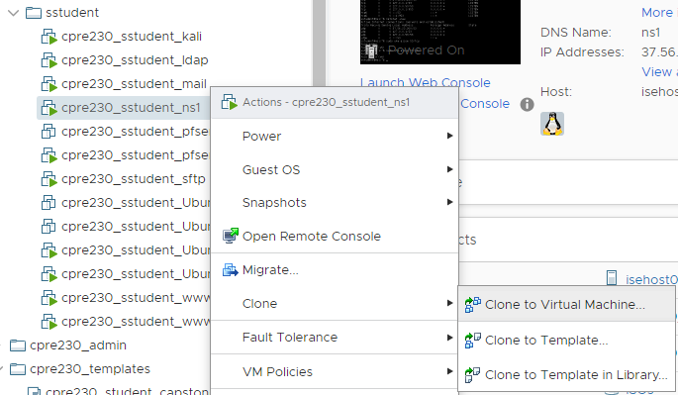
  - Follow the onscreen steps to create a cloned machine named "cpre230_<NetID>_ns2".
  - Locate your resource pool, named "cpre230_<NetID>".
  - Select cpre230 as storage when prompted for storage location.
  - Be SURE to select “Thin Provision” as the virtual disk format to avoid storage problems in the future.
  - Check the box for "Customize this virtual machine's hardware".
  - When prompted for hardware configuration, connect the network adapter to your internal network, "cpre230_myoussef_<NetID>".

Set ns2 to use DHCP
- Power on the cloned machine.
- Modify the network config settings in /etc/netplan/00-installer-config.yaml
  - Under ens160: add the line dhcp4: yes.
  - Comment out the addresses:, gateway4:, nameservers:, and addresses: lines by inserting a # before each line.
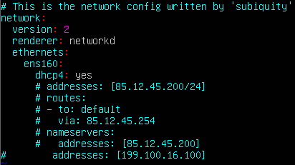
  - Save the file and then type sudo netplan apply.
  - Update the no_proxy config in /etc/profile for the internal IP range.
printf -v no_proxy '%s,' 192.168.1.{1..254}
- Reboot.
- Verify you can update and upgrade your ns2. If the machine is unable to update itself, it means there is a networking problem that needs to be fixed before moving on.

Change Hostname to ns2
1. By default Ubuntu server does not preserve hostname changes after shutdown. Enable this option in /etc/cloud/cloud.cfg by setting preserve_hostname: true
  - Set the hostname with the following command.
sudo hostnamectl set-hostname ns2
  - Reboot the machine.
  - Verify that the hostname has been updated by running the hostname command. You should see ns2 as the output.
  - Verify that you can ping the gateway (192.168.1.1) and keyhole (199.100.16.100).

Assign MAC Address Reservation for ns2
If you run an ip addr you will see that your machine now has a randomly assigned IP out of the range of 192.168.1.190-192.168.1.198. HOWEVER, you want ns2 to always be assigned the same IP address when it does DHCP so you are going to set up a MAC address reservation for it just like you did for the desktop machine.
- Using your desktop machine, open Firefox and connect to http://192.168.1.1 which is the web configurator interface for pfSense.
  - Username admin/password pfsense
- Go to the drop-down menu of Services and select DHCP Server.
- Select the LAN tab.
- Scroll to the bottom of the page
- Under DHCP Static Mappings for this Interface click Add.
- You now need the MAC address for your ns2 machine. Return to your vSphere client in your web browser and click Edit Settings, Network adapter 1, and then copy the MAC address. You may need to paste this into a text editor and then retype it into pfSense
- Return to the desktop machine with the pfSense web configurator open and paste or retype the MAC address.
- The fields that need to be filled out are listed below

MAC address | IP address | Hostname | Description
From vSphere client | 192.168.1.200 | ns2 | Ubuntu server - ns2

- Click Save and Apply Changes.
- You need to become familiar with this process because in future labs we will just tell you to add a MAC reservation for each new server.
- Before you leave the pfSense web configurator, set the DNS to your new internal DNS. You should still be in Services, DHCP Server, LAN. Scroll down the page to Servers, DNS servers, and set DNS server 1 to 192.168.1.200.
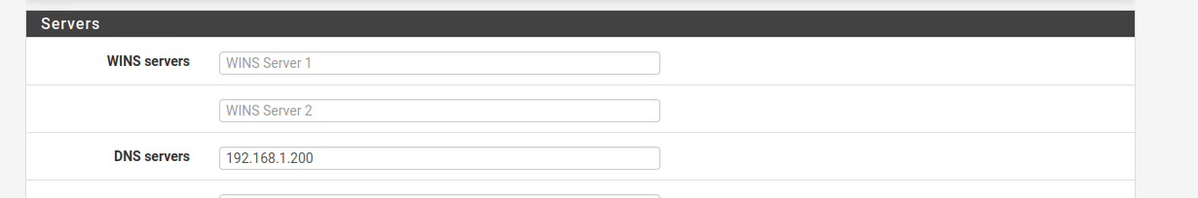
- Click Save.
- Also set the DNS server to your external DNS. Go to System, General Setup. In the DNS Servers section remove keyhole (199.100.16.100) and type in your new external DNS of X.X.X.200.
- Reboot the ns2 machine.
- Use ip addr to make sure ns2’s IP address is the one you set it to in step 8.
- Verify that DNS queries are directed at ns2's LAN IP (192.168.1.200) by running the following command: resolvectl status. The DNS Servers line should show:
DNS Servers: 192.168.1.200

Update BIND db files.
- We will now update the Bind db files providing DNS resolution. cd into /etc/bind.
  - Update the contents of db.studentXX.230.com using the information in the DNS overview table.
    - Update references in the SOA and NS records from ns1.studentXX.230.com. to ns2.studentXX.230.com.
    - Increment the serial number by 1.
    - Create a new record for ns2.
    - Use the DNS overview for the IP numbers of the internal machines that need to be included

  - Rename the db.XX.XX.XX file to db.1.168.192 and update its contents to reflect the migration table above.
    - Update ns1 to ns2 in the SOA and NS records.
    - Increment the serial number by 1.
    - On the 200 record (short for 192.168.1.200), update it to ns2.studentXX.230.com.
    - Add in the other 4 records (desktop1, ldap,ws, splunk)
  - Open the named.conf.local file, updating the "XX.XX.XX.in-addr.arpa" zone to "1.168.192.in-addr.arpa", and updating the file name accordingly.
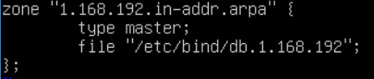
  - Open the named.conf.options file and add the following line: allow-recursion { 192.168.1.0/24; localhost; };
Note: this will allow you to resolve external addresses (like iastate.edu) by forwarding the request on to keyhole.
  - Go to the forwarders section and delete the "//" on each of the 3 lines. The "//" indicates that the rest of the line is a "comment" and should be ignored by the file parser, essentially deactivating the section.
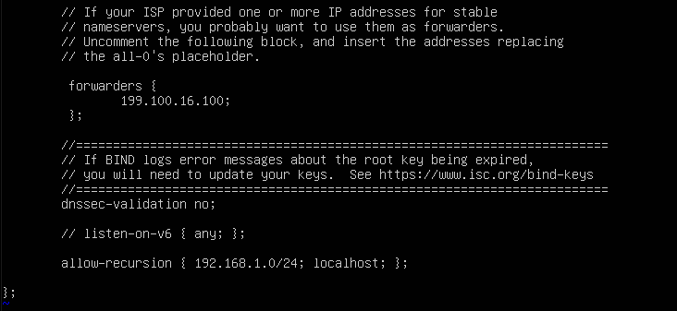
- Restart bind9 and test that updates have propagated.
  - Run named-checkconf -z to verify that the config files have no syntax errors. If there are errors, read the error message and resolve the issue. Generally, you have a typo in one of your files.

  - sudo systemctl reload bind9
  - dig ns2.studentXX.230.com +noall +answer
  - dig -x 192.168.1.200 +noall +answer
  - dig iastate.edu +noall +answer

- With the information above, test all your machines from your internal DNS server. First use the forward lookup information by asking for the machine name. Take a screenshot of 8 successful forward lookups from your ns2 (ns2, desktop1, www, mail, ldap, www2, ws, splunk).

- Then, use the reverse lookup information by asking for each IP number, which should return the name of each server. Again, screenshot each of the 8 successful reverse lookups from your ns2. You will include these images in your pdf lab report. SUBMIT SCREENSHOTS OF YOUR QUERIES IN NUMERIC ORDER

- Now, query someone else's ldap server using a forward lookup from your ns1
machine. Add this screenshot to your lab report.

- Does the ldap query on another student’s machine resolve? Why or why not? (No less than three sentences)

Nagios
Another way to test services (like SSH or DNS) is to use a network monitoring system, like Nagios. In our lab environment, we have set up Nagios Core to check on the various servers implemented throughout the semester.

Remember, you get to our Nagios instance using the web browser on your desktop machine. Go to http://monitor.homework.230.com/nagios/ and log in with monitor/cpre230. Once you’re logged in you can go to the Host Groups grid (from the left panel).

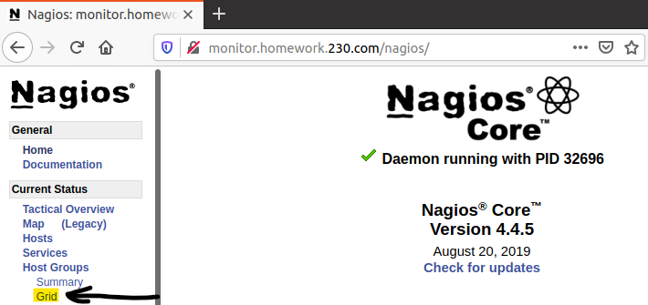

That will show you a list of all the host groups, which are the servers grouped by student number. You can click on your student number to see a more detailed view of your servers. Note: the groups are not in numeric order (i.e 10 comes immediately after 1), so you may have to do a Ctrl+F to find your group. There will be a total of eight queries for your ns1 and six queries for your ns2.
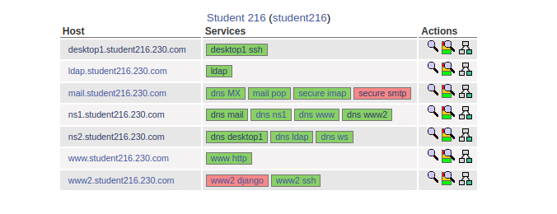
Don’t worry that most of your services will be showing red (critical) currently. They are services that will be set up in later labs. The only services you need to look at are for your ns1 server (ns1.studentXX.230.com) for this lab. You can click on the name and on “View Status Detail for This Host.” Click on that to see the different services broken out with details about their status.

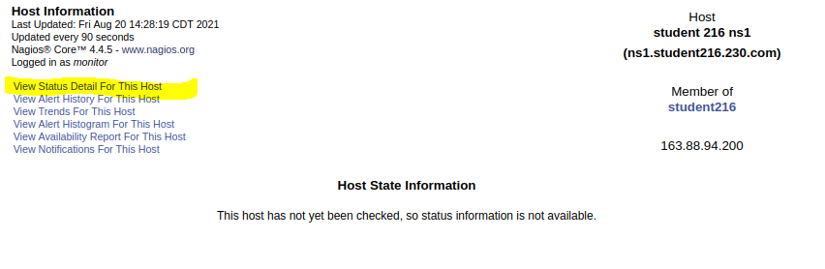

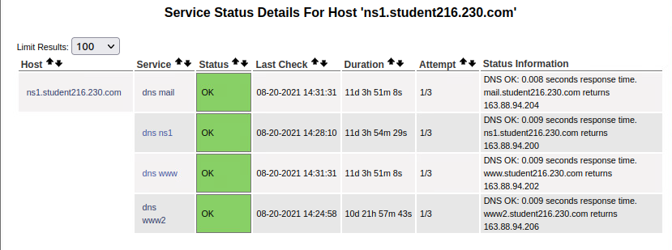
In the case of the DNS server, the check that Nagios is performing is to do a DNS query for each of your servers to see whether it gets the expected IP address.

Port Forwarding for DNS services on ns2
Because Nagios sits outside of your network, it only sees the external DNS. However, we are trying to provide Nagios as a visual representation for you to see if your services are working. The next steps would not be taken in the real world (because the Nagios server would be within your own network), but for this lab you will add a NAT rule that will allow Nagios to test your internal DNS services. You have already set a Virtual IP that points to your internal DNS (X.X.X.199 -> 192.168.1.200). Again, this is not normal and would not be done in the real world.

- From your desktop machine open Firefox and open the pfSense web configurator (refer to Lab 04.)
- Navigate to "Firewall"->"NAT" in the top navigation menu. This is you port forwarding is set up. Become familiar with these steps and understand what you are doing. In future labs you will be told to add the NAT rule without further instructions.
- Add a Separator. Click on the orange Separator button and type NS2 - Nagios checks.
- Click the darker blue Save button. This just saves the name. Then, click the light blue Save button.
- Click on the arrow down Add button. Enter needed information to forward DNS requests to the internal server. Again, this would not be done in the real world on a production network.
  - Interface: WAN
  - Protocol: TCP/UDP
  - Source: Click on the Display Advanced button
    - Type: Select Single host or alias
    - Address: 37.56.23.100 which is the IP on Nagios.
    - Leave the source port range as Any.
  - Destination: the desired Virtual IP from dropdown which is X.X.X.199 for ns2
  - Destination port range: DNS
  - Redirect target IP: 192.168.1.200
  - Redirect target port: DNS
  - Description: ns2 - Nagios DNS for inside machines.
- Click Save
- Click Apply Changes
- Check Nagios for the DNS checks on ns1 and ns2 to go to all green. Unlike the picture shown below, there will be eight queries on your ns1 and six on your ns2. (Note that this may take several minutes.) Include a screenshot in your lab report.
